COMPX223: Database Practice and Experience

Database Project: Deliverable 3

**Deliverable 3 (single student work - DB application)**

In this deliverable, you will continue to create the application which performs the tasks described below. You will use C# in Visual Studio.NET. To understand how to connect and use your database with C# in Visual Studio.Net, you should have engaged with the material provided on Moodle.

On Moodle you will find an .SQL file that contains table definitions and insert statements. This contains more mock data that you can use for this deliverable.

You are to create a Database application, with selected functionalities to be demonstrated to the tutor/lecturer. A schedule for demonstrations will be made available on Moodle.

## **What your application needs to do (Deliverable 3)**

1. Display a list of offenses (Deliverable 2)
2. Allow users to add new offenses and update past offenses.
3. View infringement notices for offenses by displaying the data similar to the example in figure 1. Note: details such logos, font, etc. do not need to be copied. Data for the Type of Vehicle, TSL No, and SRN are not in the database and so do not need to be shown.

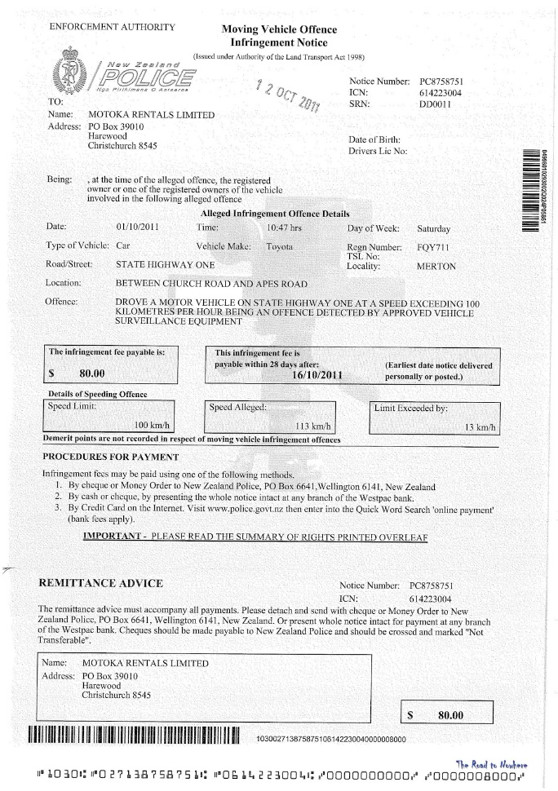

Figure 1: An example of an Infringement Notice

1. Filter the list of offences to show only offenses without infringement notices, unpaid infringements, or overdue infringements.
2. Create a summary report. This report should show a variety of aggregated data including:
   * number of recorded offenses,
   * sum of infringement fees,
   * average of how much the speed limit was exceeded by,
   * the day(s) that most offenses occurred on.
3. Interactively produce and visualise statistics about offenses. See [C# Chart Demo code](https://elearn.waikato.ac.nz/mod/resource/view.php?id=1453600) for some code to get you started. For example, show how the number of offenses is affected by:
   * Where the offense took place (number of lanes, speed limit, light conditions),
   * When the offense took place (time of day, day of week),
   * The age of the driver, or the colour of the vehicle.

You do not need to create a report but rather show the functionality to your tutor/lecturer who will give you a grade for it. In your demonstration, you should be prepared to show the following elements:

1. The data stored in your tables.
2. Show the list of offenses.
3. Demonstrate adding a new offense.
4. Demonstrate updating an existing offense.
5. Show how your application handles errors and that it is resistant to SQL Injection.
6. Show infringement notices.
7. Show how you can filter the list of offenses.
8. Show the summary report and the SQL queries used to generate the report.
9. Demonstrate how the user can select and view different offense statistics.

**Do not use any data grids for displaying or requesting any information.**

## **Grade Allocation**

For a passing grade, software for requirement 2 (show offenses) and 3-4 (entering data interactively) must be able to be demonstrated to the marker without errors and reasonable interface. To receive a high grade, all requirements above (1-9) must be completed to a high level (good interface, error handling, working smoothly)